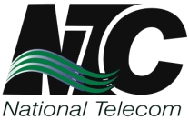
NATIONAL TELECOMMUNICATION CORPORATION
Headquarters G-5/2, ISLAMABAD

CANCELLATION OF TENDER
Tender No. HQ/ADV-02(C)/2024-25

Provision of ManageEngine OpManager AMS License Renewal and Training
Reference is made to our above mentioned tender notice published in daily “Dawn” & “Nawa-e-Waqt” on 17th August, 2024 and uploaded on PPRA website. The tender has been “Cancelled”. The office of Director (Procurement) may be contacted for detail or any query.
Director (Procurement)
Ph: 051-9245833, 9245975 Fax: 051-9245719 Web: www.ntc.net.pk

Size 5 x 2

